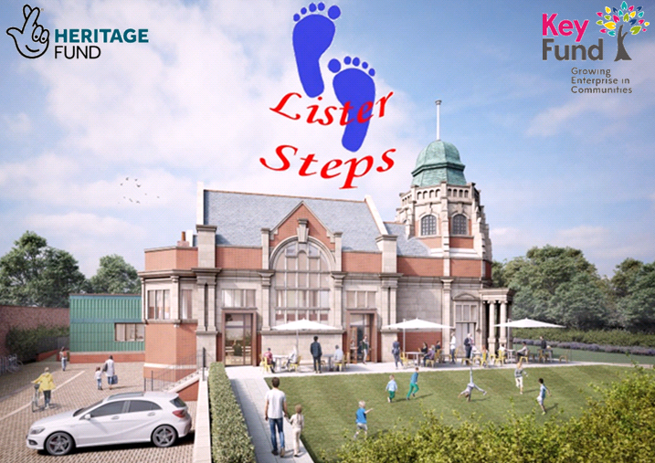

Volunteer enquiry form: The Old Library project

Thank you for applying to volunteer with Lister Steps and The Old Library project.

Please complete this form and return it to us via post or email:

Olivia.Johnson@listersteps.co.uk

Olivia Johnson
Lister Steps,
Old School Site,
Lister Drive,
Liverpool
L13 7HH

If you have any questions about your application, please do not hesitate to get in touch. We look forward to hearing from you.

‘Lister Steps is committed to safeguarding and promoting the welfare of children and young people and expects all staff and volunteers to share this commitment.’

Personal details
Title |  | Surname |  |  | Forename(s)
Address
 |  |  |  |  |  | Postcode
Home telephone |  |  |  | Mobile telephone
Email address

Volunteer role applied for
Tell us a bit about why you’d like to volunteer with us.
What could you bring to this role? Tell us about the skills, interests and personal qualities that make you a great volunteer.

At Lister Steps, we’re passionate about bringing The Old Library back to life. Why do you think this project is important?
Where did you see this role advertised?
Please give us an indication of when you’re available to volunteer (if you are applying for a short-term role, please indicate the relevant dates you can volunteer)
 |  | Evenings | How much time can you give?  (e.g. one hour per week, one day per week, one day per month, etc.)
 |  | Weekends
 |  | Weekdays

